Effective paragraphing is a central skill in academic writing. Paragraphs come in different shapes and sizes, and some so-called “rules” may limit writers and unnecessarily hamper their ability to convey ideas as needed in a particular piece of writing. Nevertheless, grasping the general form of a paragraph provides a good foundation. Once you have this basic building block at your command, you can vary from it when necessary.
Paragraphs are the building blocks of your nursing science paper. When you are writing paragraphs, it’s useful to think about the M.E.A.L. Plan when organizing your sentences.

M=Main Idea
This is the paragraph’s central point, tied to the larger claim of the paper. Some writers may have learned this as the “topic sentence,” but it doesn’t necessarily need to be the first sentence.

E=Evidence
Part of the paragraph’s “main course.” This could be information from peer-reviewed journal articles, data from research or interviews, clinical scenarios or anecdotes, among other forms of support. Evidence cannot “speak for itself.” As the author, you must link the evidence to your arguments. Evidence and analysis often weave together throughout a paragraph.

A=Analysis
Always analyze the evidence you provide in your paragraph. Explain EXACTLY how the evidence you’ve cited proves what you think it proves.

L=Link
A link can be implicit OR explicit. A reader MUST “get” a clear sense of how the paragraph fits into the larger scheme of paper’s argument, or how this paragraph links to the next one.

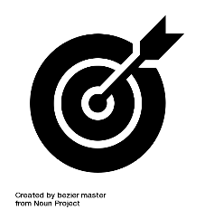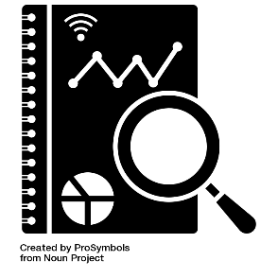
Adapted Summer 2020, based on work from the Thompson Writing Program at Duke University. For more information, see: http:://twp.duke.edu/writing-studio
Prepared by the Office of Learning and Writing Support

