What? An annotated bibliography is a summary and evaluation of references you will be using for a research paper. The length and content will depends on your specific assignment, but it typically is in paragraph form and includes:
- The reference citation (in APA 7th edition format)
- 2-4 sentences summarizing the main ideas of the source
- 1-2 sentences to evaluate the reliability, objectivity, and quality of the study.
- 1-2 sentences to reflect on the source (For example: Was the source helpful? How you will use it in your paper? Has it changed how you think about the topic?)

Why? An annotated bibliography is preparation for a research paper. When you have to write annotations for each of your sources (an annotated reference), you are required to read each potential source carefully. Annotated references are descriptive, critical, and reflective. Writing one helps you organize and assess the sources you have found to support the overall argument or thesis of your work.
Reference in APA format

Example annotation

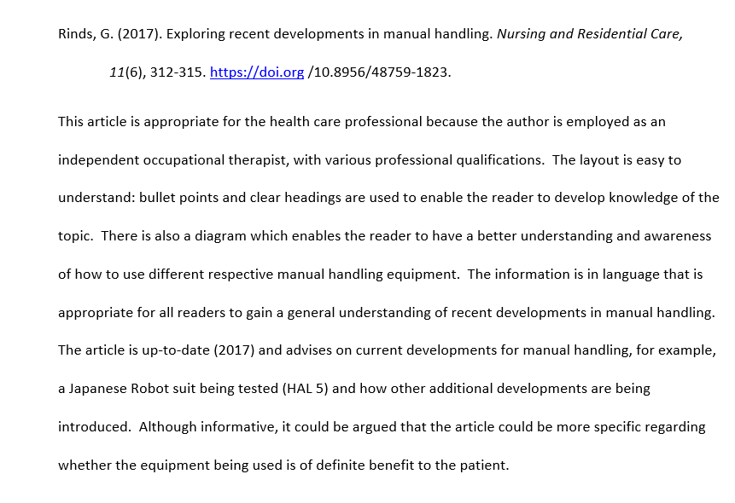
Final sentence: A critical appraisal of the article.
These next few sentences speak to the relevance, clarity, and organization of the article and summarize the topics covered.
Statement on the reliability of the source (Here, it’s the author’s qualifications)

*Adapted from: https://www.slideshare.net/HolllS/what-is-an-annotated-bibliography
Prepared by the Office of Learning and Writing Support

