APR Self-study Resources
These resources are intended to help programs develop their self-study, but they are not considered definitive. We encourage programs to use information from these and other resources beyond what is provided in this list.

Section III, Subsection A: Program Mission, Purpose, and Goals
These contacts can help your program with completing this section of the self-study, which communicates the program’s current mission, purpose, and goals.
- Strategic Communications
- Government and Community Relations: Ellie Boggs (State Relations)

Section III, Subsection B: Assessment of Student Learning
These resources will help your program with accessing information and support for your report on student learning assessment. Your program’s Assessment Council program rubric scores and feedback are also a required part of Section VI. Supporting Documentation in the self-study. See the instructions near the end of this document to access that information.
- Assessment Council
- Assessment Academy
- Provost Assessment Awards
- OCTRI: Evaluation Assistance Program (at cost)

Section III, Subsections C, D, and E: Learning Environments, Faculty, and Teaching Evaluations and Faculty Development
These resources include a variety of contacts, training, and support options to help foster a safe, respectful, accessible, and inclusive learning environment for students. They may also help your program in analyzing trends of recruitment, retention, and departure/retirement of faculty. Award opportunities are also noted.
Contact the Teaching and Learning Center (TLC) for consultation on topics such as assessment, curriculum development, digital accessibility, technology-enhanced learning, online course development, and faculty development.
- Educators’ Collaborative
  - Education Grand Rounds
  - Pods and Seeds
    - Teaching, Learning, and Assessment Pod
    - Training and Instructional Design Pod
    - Educational Scholarship and Research Pod
    - Health Equity Pod
- Educational Improvement and Innovation
  - Foster Respectful and Equitable Education
    - Initiative to build OHSU clinical and non-clinical educators’ skills in implementing and integrating equity-centered curricular strategies for learners in health professions education.
    - Contact FREE@ohsu.edu for information about the FREE Certification micro-credentialing program, workshops, and resources.
  - Mentorship and Career Design
  - Education Scholarship
  - Educator Succes Grants
- Teaching and Learning Center
  - Course Evaluation
  - Train Your Brain (collaborative learning series)
  - Accessibility Resource Center
  - Training Future Faculty
  - Clinical Teaching Resources
  - Teaching Observation and Coaching
- Interprofessional Education
  - IPE Education Curriculum Development Award
- Faculty Senate awards

Section III, Subsections F and G: Students and Student Services and Career Development
These resources can aid you when reflecting on student support services offered at OHSU and how your program refers students to these resources.
- Student Support (Office of Student Affairs) offers direction to the following:
- Health and wellness
- Consultation, Awareness, Resources, and Education (CARE) Program
- Accommodations for disabilities
- Academic Success Center
- OHSU Library
- Educational debt counseling and financial management
- Food assistance
- International student support
- Student Interest Groups
- Academic Policy

Section III, Subsection H: Budget/Obligations, Tuition, and Resource Utilization
These resources can help your program when gathering information on student scholarship opportunities, external funds, financial aid, and awards.
- Financial Aid and Scholarships
- Scholarships for Undergraduate Medical Education students
- School of Dentistry scholarships
- School of Nursing scholarships
- OHSU-PSU School of Public Health graduate scholarships
- Office of Proposal and Award Management (OPAM)
- OHSU Strategic Plan

Section VI: Supporting Documentation
This section requires programs to include their most recent Assessment Council program rubric and scores. To access this information, use the Assessment App and go into your program’s historical data. Then, click the feedback tab, select the most recent academic year, and then click download. See the image below for a visual depiction of these instructions:
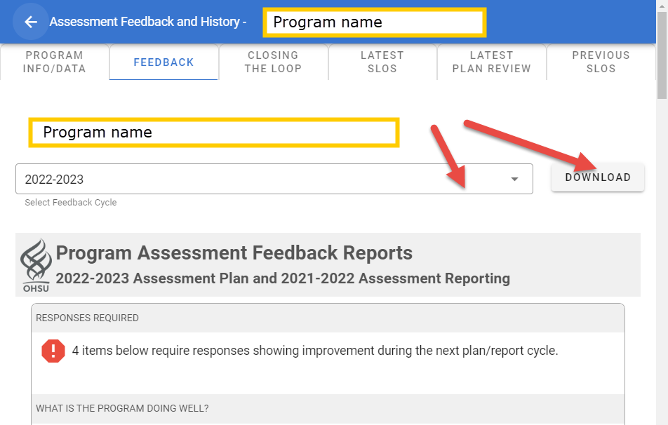

Additional Resources
- Accreditation

