OHSU-Linked OHA Death Data

The following is information about OHSU-linked Oregon Health Authority (OHA) death data. The request process is facilitated by the OCTRI (Oregon Clinical and Translational Research Institute) Clinical Research Informatics Research Data Warehouse (RDW) team and the Research Data Concierge (RDC). The process involves data that are already stored in the OCTRI RDW.

How to Make a Request and Ask Questions
Intake is via the OCTRI Research Request form

Questions can be directed to the Research Data Concierge: researchdata@ohsu.edu

General Information
Only deaths that occur in the state of Oregon are included. Information from the OHA has been matched to OHSU patients, and the matches validated. After matching, information is deleted that is not associated with an OHSU patient. Data are available from 2006 and onward. Data are obtained each fall for the year prior. For example, in fall of 2021, data through the end of 2020 were obtained.
Available data types include date of death, cause of death and related info, and demographics. More details are available on request.

Data are available in the OCTRI RDW, but submitting a data use agreement (DUA) to the OHA is still required. The study team will add specific information about their study to a pre-filled DUA template, and will also collect signatures from all team members who will be accessing the data. The Research Data Concierge will collect the OHSU Contract authority signature, and submit the DUA on behalf of the study team.

Due to OHA restrictions, OHA death data are not available for industry-sponsored projects.

There is no charge from the OHA, but there may be a charge from the RDW team for extracting the data. Cost will be based on the standard hourly RDW cost ($160/hr.), and may vary substantially across different projects depending on project scale and the extent of the data to be extracted. For non-cancer research, the cost is expected to be ~ $640 (or 4 hours of time). Cancer-related projects may be covered by resources supported by the Knight Cancer Institute, and therefore be free of charge.

Reminder: OHA death data cannot be shared with anyone other than the designated recipients approved by the OHA, who have signed the OHA data use agreement. Data cannot be sent to OHSU’s Epic Electronic health record (EHR) — even if the information from OHA conflicts with Epic information.

Example Timeline
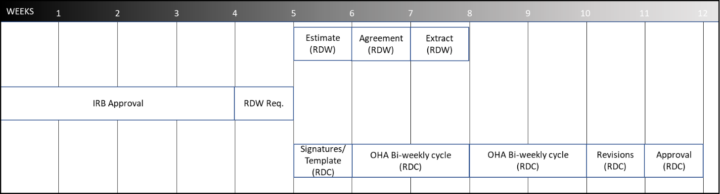
- Please note this is just an example. Actual timelines could be shorter or longer depending on the project.
- RDW = RDW team facilitates this process
- RDC = Research Data Concierge facilitates this process

