Classroom and Clinical Assessment Handout
Planning for Learning and Assessment

Competency or Course Objectives​ | Unit or Sub-Objectives​ | Formative  Assessment​ | Summative  Assessment​ | Activities and Resources​
Example: ​  CO #1: On their term paper, learners will be able to clearly and ethically cite their sources. ​ | Learners will be able to correctly cite resources using APA format.​ | •Interactive self-test​ | •Term paper ​  •Final project​  •Presentation ​ | •Citation Jeopardy ​  •Purdue OWL (Online Writing Lab)​
​ | ​ | ​ | ​ | ​
​ | ​ | ​ | ​ | ​
​ | ​ | ​ | ​ | ​
*This table can have multiple names and can include multiple components linking objectives to assessment and learning activities:​
Planning for Learning & Assessment, Banta TW, Palomba CA. Assessment essentials: Planning, implementing, and improving assessment in higher education. John Wiley & Sons; 2014.​
Curriculum map for a course syllabus, Suskie L. Assessing Student Learning: A Common Sense Guide. San Francisco: Jossey-Bass; 2009.​
Syllabus format for outcomes, pedagogy, assessment methods and criteria, Maki PL. Assessing for learning: Building a sustainable commitment across the institution. Stylus Publishing, LLC; 2012.

Active Verbs Developed Based on Bloom’s Taxonomy

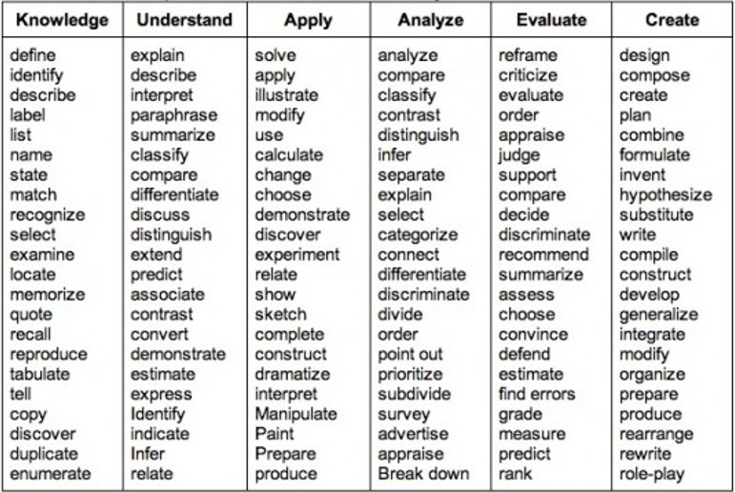
https://www.mesacc.edu/employees/academic-scheduling-and-curriculum/resources/blooms-higher-level-verbs
​

OHSU Graduation Core Competencies

Professional Knowledge and Skills ​
Demonstrate core knowledge, skills, and practices as defined by the discipline, professional licensing, or accreditation organization while being open to new perspectives, additional voices, and changes in schools of thought that impact the core knowledge, skills, and practices in the discipline. ​
​

Professionalism ​
Demonstrate discipline-specific behaviors, norms, and ethics and also challenge systemic racism inherent in professional expectations that cause undue burden and/or deny the full humanity of ourselves, our peers, and our patients. ​
​

Information Literacy ​
Recognize the power of information in educating, influencing, and understanding the world, while seeking and amplifying missing perspectives. With this lens, locate, critically evaluate, and effectively use information to participate in decision-making, quality improvement, and broader scholarly discourse. ​
​

Communication ​
Communicate effectively and equitably with diverse individuals, organizations, and communities to support stakeholder decision-making and promote culturally responsive exchanges of information. Teamwork Work effectively within collaborative, team- or teaming-based interprofessional environments while acknowledging positionality and intentionally making space for diverse perspectives. ​
​

Teamwork​
Work effectively within collaborative, team- or teaming-based interprofessional environments while acknowledging positionality and intentionally making space for diverse perspectives.​
​

Community Engagement, Social Justice and Equity ​
Apply principles of social justice, equity, and/or anti-racism through community-engaged practice, service, or scholarship. ​
​

Patient Centered Care ​
Clinical degree program graduates will collaborate with diverse individuals, families, and communities to provide quality trauma-informed care that is anti-racist and respectful of and responsive to preferences, needs, attitudes, beliefs, and values.​

OHSU Assessment for Learner. Core Competencies. https://www.ohsu.edu/education/assessment-learners. Accessed March 2, 2023

