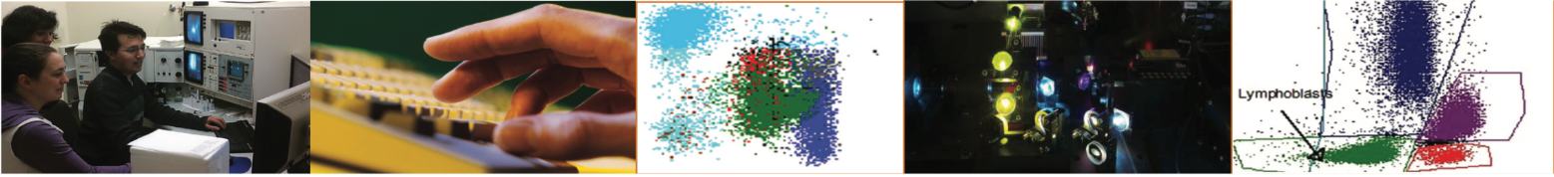

The OHSU Flow Cytometry Shared Resource (FCSR) has operated as a core resource for OHSU investigators since 1996 and provides advanced flow cytometry instrumentation, technical expertise and technical services.
Richard Jones Hall:
- BD Symphony
- BD LSRII
- BD Canto
- Beckman Coulter Cytoflex S
- InFlux (Spock)
- InFlux (Kirk)
- Miltenyi AutoMACS
- Luminex 200
- CyTOF Helios

Introduction

The Flow Cytometry Shared Resource (FCSR) personnel provide training in data interpretation, experiment design and routine instrument operation, offering investigators the
cost-saving option of doing some of the work themselves. Resource personnel also support investigators by providing operator-assisted fluorescence-activated cell sorting, analytical flow cytometry and data analysis.
Equipment:

Operators:
Pamela Canaday
Reshma Purohit
Christina Metea

Director:
Phil Streeter
Knight Cancer Research Building:
- BD Fortessa
- BD Symphony A5
- BD Symphony S6 (sorter)
- BD ARIA Fusion (sorter)
- CyTEK Aurora

Services:
1. Quantitative measurement of fluorescent reporters to assess the distribution of specific molecules within cell populations.
2. Sorting to isolate purified cell populations based on detection of specific probes such as antibodies and fluorescent proteins.
3. Analysis of multiple characteristics such as relative cell size, antibody binding to cell surface or intracellular biomarkers, DNA and RNA content, and fluorescent protein expression.
4. Functional assays to measure apoptosis, enzyme activity or calcium flux.
5. Cells can be sorted into 5-15 mL conical tubes, Eppendorf tubes or into multi-well plates.
6. After acquisition of data, investigators will receive data files and/or data plots. In addition, for sorting experiments, investigators will receive sorted cells and an analysis of post-sort purity.
7. Researcher training for analytical instrument use

