How to be a Great Mentee
“The Search” – Finding a mentor who is the right fit for your professional development
Step 1: Reflect and Write
- Understand your core values and mission  Write a mission statement  - Know your work style and habits  - Identify knowledge and skill gabs  - Be specific in desired opportunities and goals  Complete an Individualized Development plan (IDP) | Li ST, et al. Using your Personal Mission Statement to INSPIRE and Achieve Success. Academic Pediatrics. 2017; 17(2):107-109.
My mission is to:
Step 2: Spend time in the Search
Look for a mentor who:  - is available and accessible  - helps mentee develop own agenda  - provides opportunities  - encourages mentee to take risks  - has mentoring experience | Next steps in my mentorship search:  1.  2.
Step 3: Create a mentoring team | Step 4: Build the relationship – Manage up!
Look for mentors with complementary strengths who can make different contributions to your development  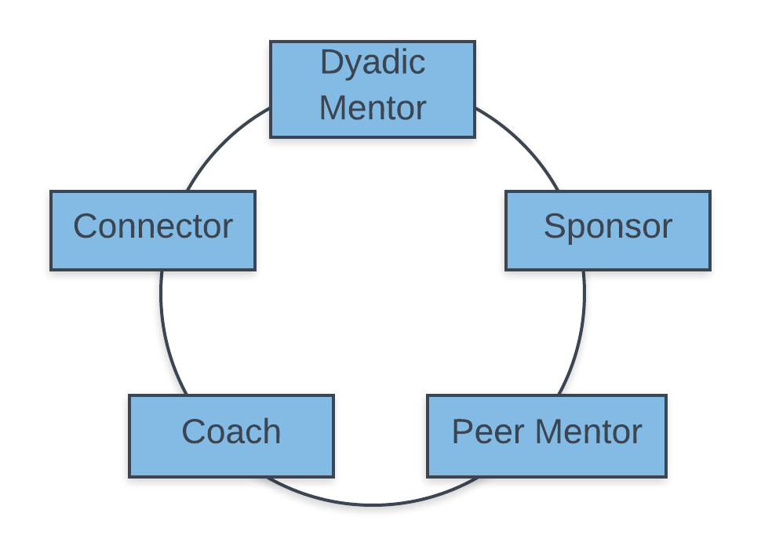 | - Manage up  Set goals and expectations  Plan a meeting schedule and agenda  Summarize and follow through on tasks  - Ask for (and accept) feedback)  - Ask questions  - Actively listen
To become a GREAT mentee, I need to:
1.

2.

