A strategy to reduce and control COVID-19 hazards
This section provides a "big picture" framework. It uses elements that can be modified as conditions change. This section doesn’t describe every technical detail. It does provide additional references and sources at the end. These resources can help construction employers find more details.

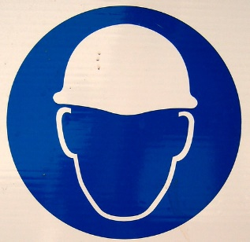
Step 1: designate a COVID-19 Site Safety Officer
"Hard-hat" by psd is licensed under CC BY 2.0
Coordination and accountability are critical. However, your worksite may use a different title. This designated person could be like a "competent person" for a small firm or project. They could be a safety or health professional at a larger company or worksite. Employees and subcontractors should know who this person is and how to contact them. This person should have a comprehensive understanding of
- how COVID-19 can spread
- the value of certain controls related to potential exposure
- how to effectively implement additional controls for specific situations
This person should have the authority to implement additional controls as needed.
What construction workers need to know about COVID-19 – read on CDC site

Step 2: develop a COVID-19 control plan
A plan spells out roles, responsibilities and actions. OSHA’s Guidance on Preparing Workplaces for COVID-19 includes information on how to develop an "Infectious Disease Preparedness and Response Plan".
COVID-19 Control and Prevention Construction Work – read on OSHA site

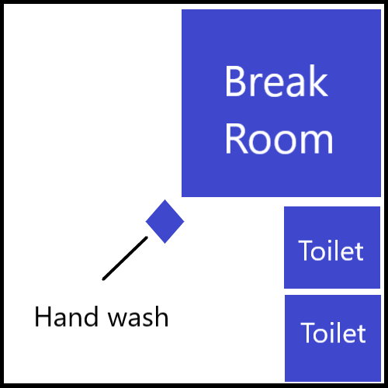
Step 3: review a site map to guide location of COVID-19 control measures
Obtain and review a map of the site. Do this while developing a response plan. A map of the worksite, a worksite walk-through and the size of work crews helps planning. They make it easier to visualize
- common areas
- break areas
- potential employee density and "choke" points
- movement and flow around the site
- likely high touch surfaces for further attention
- optimal locations for sanitation stations
Your team can use the site map for site orientation and sharing the overall plan.
Reference: pp. 11 to 12 of Focus on Construction Health:COVID-19 Guidance Document by AIHA (American Industrial Hygiene Association). Resource found at New Guidance to Help the Construction Commuinity Deal with the Challenges of Responding to COVID-19 (5/4/2021). Direct link to document https://aiha-assets.sfo2.digitaloceanspaces.com/AIHA/resources/Guidance-Documents/Focus-on-Construction-Health-COVID-19_AIHAGuidanceDocument.pdf
"Hard-hat" by psd is licensed under CC BY 2.0
Reading Level grade 9.2

