Sample COVID-19 After Action Report

- Clinic Name:
- Event Name: COVID 19 Outbreak 2020
- Event Begin Date: March 9,2020
- Event End Date: Feb 2021 ( for purposes of this report)
- Duration: 11 months
- This event in 2020 occurred as a result of a Corona Virus from Wuhan, China which resulted in a worldwide Pandemic.

The purpose of this report is to analyze event results, identify strengths to be maintained and built upon, identify potential areas for further improvement, and support the development of corrective actions that will guide future emergency preparedness initiatives to advance overall emergency preparedness within our clinic.

- Jan 22, 2020 The Center for Disease Control (CDC) confirmed first COVID-19 case in the U.S.
- Jan 30, 2020 The World Health Organization (WHO) declared the outbreak a public health emergency (PHE) of international concern.
- Jan 31, 2020 HHS Secretary Azar declares a PHE in the U.S.
- March ?, 2020 Governor ________ declared a State of Emergency and activated the Emergency Operations Center.
- March 11, 2020 The COVID-19 outbreak characterized as a pandemic by the WHO.
- March 13, 2020 President Trump declares a National Emergency concerning the COVID-19 outbreak.
- Jan 2021, the Acting HHS Secretary extended the PHE to April 20, 2021.

- Executive Summary. The emergency team was composed of _________ (names of staff in leadership)

Major Strengths:

Staff training conducted on infection prevention
Plan to triage patients who come to the clinic
Plan to put a sign on the door to go back to car and call.

Staff Training:

Telehealth
Donning and Doffing PPE
Patient screening protocol
Staff screening

Areas of Improvement

Need to order extra PPE supplies such as masks and hand sanitizer earlier
Need to minimize things in the waiting room to decrease things needing disinfecting.
Need for more screening of clinic staff, temps in the morning
Need to set up refill process during Pandemic or epidemic
Need for more telehealth
Public service announcements to tell community we are seeing patients
Need to change message on answering machine
More local testing

Event Successes
Staff immediately began calling patients instead of visit to decrease exposure for patients
Some staff sent to hospital to assist with surge
Recruited some experienced staff from hospital to help with triage
Sign on door sending patients to the car to call
Limited seating in the waiting room
Extra hand sanitizer and tissues in the waiting room

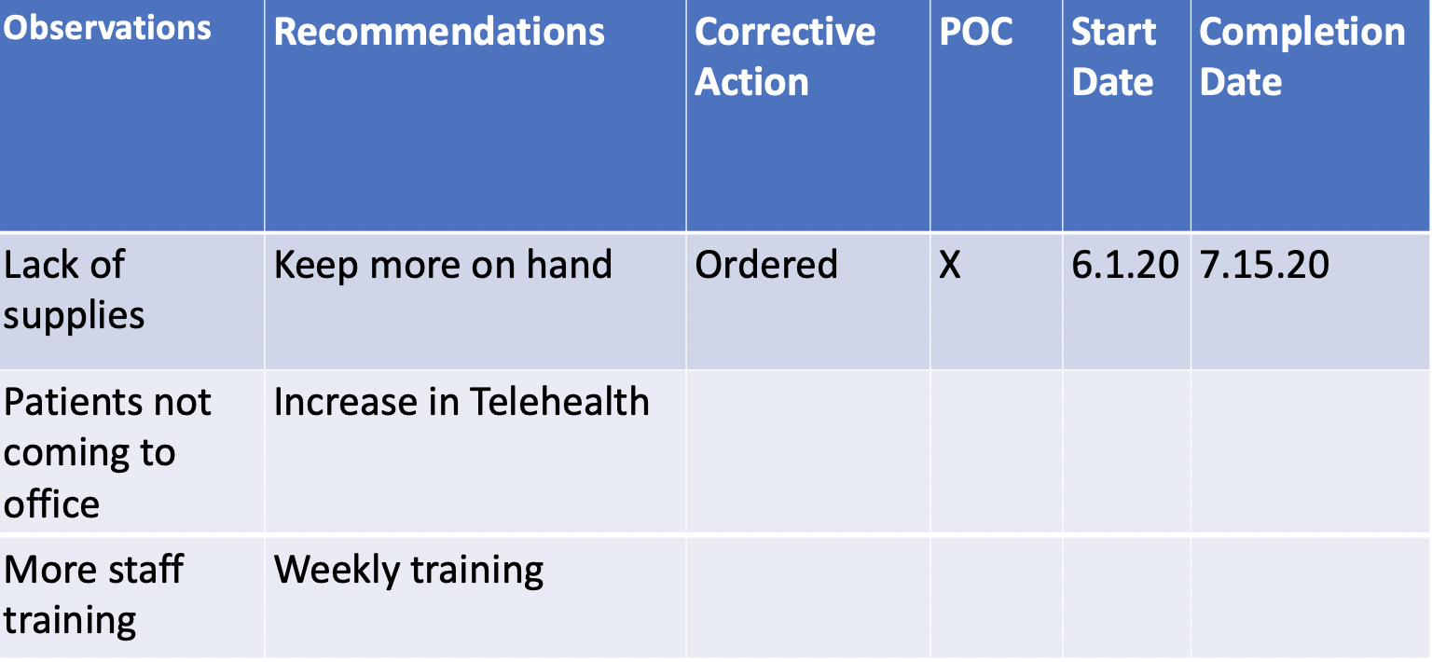

Process Implemented

Masks
Phone Screening
Taking temps on patients entering the clinic
Dedicated entrances
Dedicated exam rooms
Extra cleaning
Questionnaires re exposure, symptoms
Sign on door
Restriction of people accompanying patients
Collaboration with other facilities
Moving healthy patients to another site
Re-allocation of some staff

Analysis Meeting

- Report reviewed with staff
- Assignments given
- Attendance log at AAR meeting

