**Registration**

OHSU will validate patient registered for vaccination. We receive a waitlist from Public Health. Please direct scheduling questions to Public Health: **503-397-7247**

30 Minutes– Indicate patient needs extended observation.

Clinic Entry

**DOOR 2 -** Lobby

**DOOR 4 –** Conf.Rm

FLAG & DOT GUIDE

Blue to indicate ready for vaccination

Green to indicate patient under monitoring

Black to indicate patient done & Room to be cleaned

**FLAG DOWN** after room clean

VACCINE RUNNER

Leads-LIP will run & request additional vaccines to help prevent vaccine waste.

Exit through Door 3

* + Eligible Patients are currently being contacted & registered through **Public Health via SignUp Genius**
  + Lists will be printed for validation at Check-in

**Welcome Screening & Check-in – Greeters & Check-in**

* + Patients will be greeted outside of clinic & screened for COVID symptoms & Allergies
    - **30 Minutes – Give red card to indicate allergy risk**
  + Once confirmed, Check-in will check for active Chart or create new “lite” Registration
  + Add Appointment to Schedule
  + Check-in Patient & direct to Door 2 or Door 4

**Rooming & Scribing – Scribe**

* + Scribe will pull from door for their pod
  + Room & Open Encounter: Validate info, inform of plan and ask to prep shoulder
    - **Questions will be addressed by LIP**
  + SCHEDULE Follow-up Vaccine in 4 weeks
    - **If unavailable, Patient must stop at Front Desk to add to Waitlist**

**Vaccination – Vaccinator/LIP & Scribe**

* + Vaccinator/LIP will address any questions or concerns
  + Administer Vaccine
    - **SCRIBE** to Record administration in EPIC
  + Instruct patient about self-monitoring
    - **30 minute monitoring – Lead patient to Conference room for observation**
  + Record admin time on whiteboard

**Monitoring – Monitors & Triage**

* + Monitors & Triage will check-in on patients
  + Callout for assistance or medical questions
  + Release patients after monitoring & clean room

Follow Signage

**Discharge – Monitors & Front Desk**

* + Patients will be exiting through **DOOR 3**
  + **Waitlist Patients** exit through Lobby to speak with Front Desk

**Clinic Role Today:**

*Welcome & Screening*

1. **Greeter – Check-in** is stationed outside door #3 and will **verify the patient has an appointment & check-in.**
   1. If patient screens positive on COVID symptom screen, will likely have to re-schedule. Please contact the LIP on duty for assistance.
   2. Otherwise, have them move to check-in
   3. **Check-in will validate and check patient in**
      1. **If patient screens in low risk group (green) on vaccine triage questions, direct patient to door #2 or door #4 to meet one of the scribe/navigators to get roomed. These patients will require 15 minutes of observation after vaccine administration.**
      2. **If patient screens in medium risk group (yellow), give patient a yellow laminated sheet and alert them they will need to be observed for 30 minutes after vaccination. If they have questions around safety, please alert the LIP on duty for assistance.**
   4. **If patient screens in high risk group (red), they will require a referral to allergy prior to vaccination. Do not vaccinate on site.**
   5. **Greeters should have walkie-talkies to be able to access triage. Patient may call the helpdesk (main clinic number) for assistance scheduling if they don’t have an appointment (we will take waiting list in case there are vials with doses remaining at the end of each session).**

***NOTE – Please hand out Time Study cards about every 10 patients.***

**Primary Responsibilities:**

* + Verify appointment – Printout & appointment
  + Add mini-Registration 🡪 **PAGES 3 & 4**
  + Hand out CDC info about Vaccine
  + Provide **30 Minute** sheet to indicate extended monitoring
  + Inform of Waitlist – Taken at Front Desk
  + Direct to Door 2 (the Lobby) or Door 4 (Conference Room)

**Common Questions & Issues:**

* + I’m registered but my husband/son/daughter/friend also need it but aren’t registered, can they get a shot today?
    - They need to get on the waitlist and we’ll call and offer at the end of the clinic, if we have extras.
    - If not in current group, they must wait until their group is active.
  + Patient thought they registered but didn’t, or signed up under wrong name.
    - Patient needs to correct registration through the SignUp Genius portal from Public Health.
  + Public Health: **503-397-7247**

QUICK GUIDE FOR REGISTRATION & CHECK-IN FOR NEW PATIENTS

* Patient Lookup 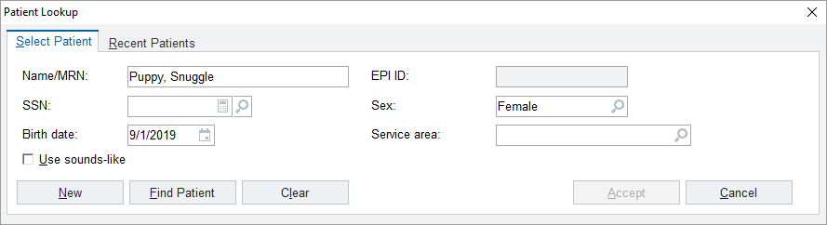
* Type in name: click “find patient” (if pt has never been seen before you can go to “New”
* Create MRN (if never been seen at OHSU)
  + If there is an MRN verified Demographics
* Address
* Phone number
* Date of Birth
* Sex
* Language
* Email: (Patient Unavailable for Email)

Schedule appointment:

* Reg Visit information
  + Accident Related? No
  + Farm worker status: no
  + Homeless Status: no
  + Public Housing? No
  + Self-Pay Descriptor – X92 Self Pay: Do Not Bill Insurance
  + Account Selection:
    - Check Guarantor Accounts box
    - Check Do not bill insurance box

Go to Checklist (off to the right side from Registration) 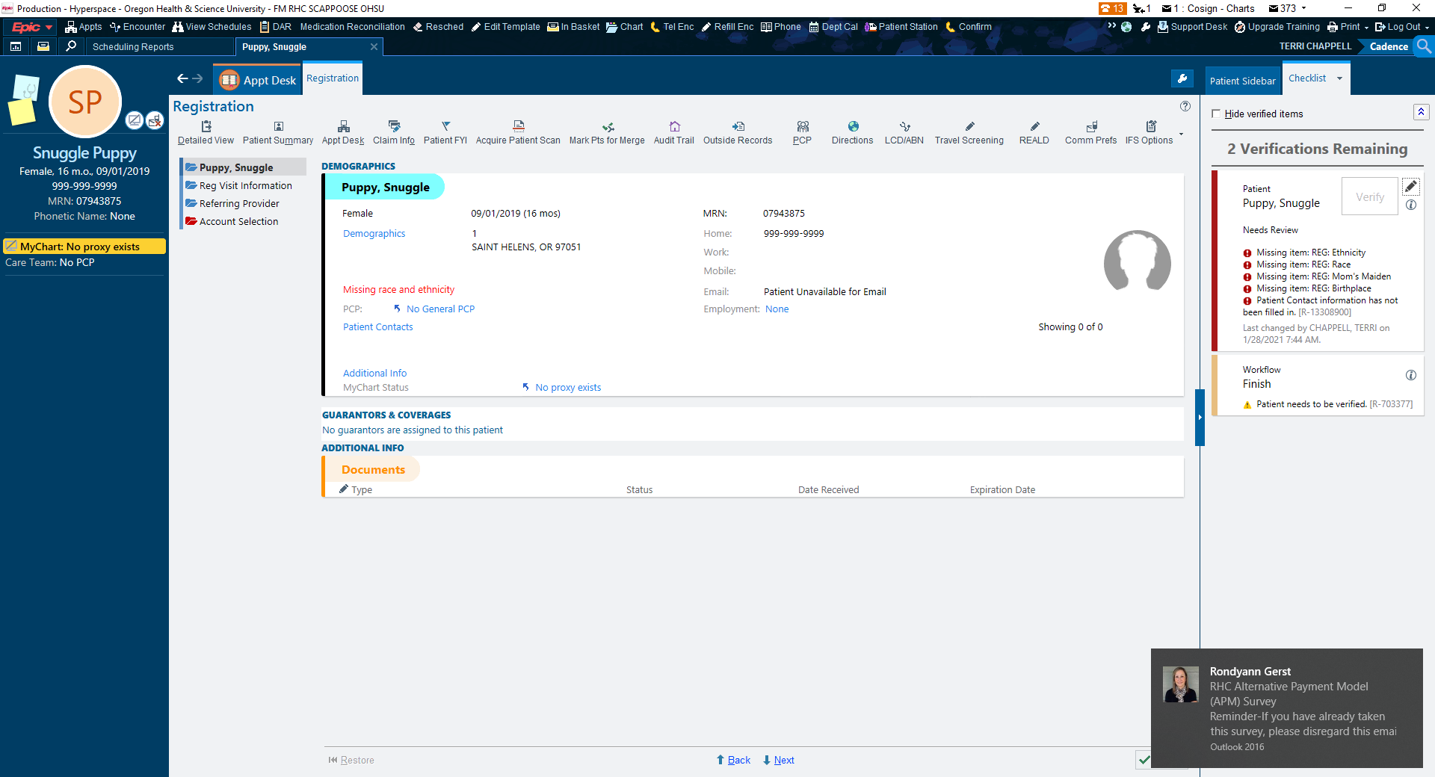

* + Click on the Pencil
  + Change status to “Needs Review”
  + Accept

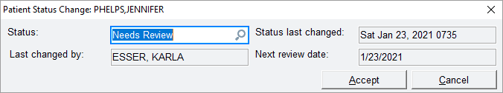

Accept

Finish

You will see a yellow warning sign, click “continue” this will bring you back to the main appointment desk screen

* By doing those steps you will be able to check in the patient

Check the patient in