EDUCATIONAL RESEARCH IRB INITIAL APPLICATION TIPS

NO RESEARCH CAN PROCEED UNTIL YOU HAVE RECEIVED AN IRB REVIEW & DETERMINATION

The determination may result in the IRB deeming your project as exempt or not human subjects research. You could also get an expedited approval if it is a minimal risk study or approval after full board review for greater than minimal risk studies.
Use the following list to confirm that all required steps of the IRB Application process are completed.
- CITI Training: The entire study team should complete CITI training before submitting the IRB application https://www.ohsu.edu/xd/about/services/integrity/training/upload/Instructions-for-first-time-CITI-users-2.pdf

- Conflict of Interest Disclosures: The entire study team must complete

  - Conflict of Interest Disclosure Forms for Researchers: https://bigbrain.ohsu.edu/coi/

- eIRB system: The PI should register in the eIRB system https://ohsu.ellucid.com/documents/view/7726/?security=a0530e48f5673c9ff86bd76793a4a0ad91ff5c0d

- Study Type: The researcher using human subjects should completed an electronic IRB often “Protocol Template, Minimal Risk” or “Expedited Review…”. (If you do not know your study type, complete a request for determination form).

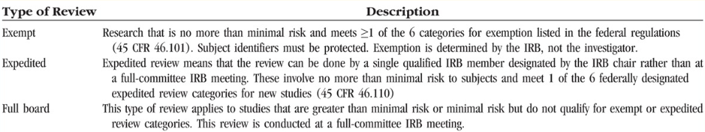

- OHSU Templates: The researcher completes the protocol, informed consent forms, and other instruments that will be used for research within the eIRB system. (see templates)

Exempt: Complete the IRB determination form and cite either 45 CFR 46.104(d)(1): Research involving normal educational practices not likely to adversely impact students’ opportunity to learn required educational content or the assessment of educators who provide instruction such as: (1) Most research on regular and special education instructional strategies; or (2) Research on the effectiveness of or the comparison among instructional techniques, curricula, or classroom management; or
  - 45 CFR 46.104 (d)(2): 45 CFR 46.104 (d)(2): Research that only includes interaction involving the use of educational tests (cognitive, diagnostic, aptitude, achievement), survey procedures, interview procedures or observation of public behavior (including visual or auditory recording) if at least one of the following is met:
      - Information obtained is recorded by the investigator in such a manner that the identity of human subjects cannot be readily ascertained, directly or through identifiers linked to the subjects;
      - Any disclosure of the human subjects’ responses outside of the research would not reasonably place the subjects at risk of criminal or civil liability or be damaging to the subjects’ financial standing, employability, educational advancement, or reputation or;
      - The information obtained is recorded by the investigator in such a manner that the identity of the human subjects can be readily ascertained, directly or through identifiers linked to the subjects, and an IRB conducts a limited IRB review to make the determination required by 45 CFR 46.111(a)(7).

Expedited: Complete the Minimal Risk Protocol Template
  - Answer all questions in as much detail as possible (See example)
  - Upload all study materials, such as surveys, information sheets or consent forms, e-mails to contact students, etc (See examples)

Full Board: Complete the Protocol Template
*if study is unfunded, complete a proposed project questionnaire form: https://www.ohsu.edu/xd/research/administration/rda-forms.cfm#ap
  - Answer all questions in as much detail as possible.

    - Data security: For example, give the length of time that the data will be stored, where it will be stored, and when it will be destroyed. What is the sensitivity of the data you will be collecting and the potential risks to research participants if there were a data breach. See confidentiality and security checklist: https://ohsu.ellucid.com/documents/view/7698/false

- If your plans or instruments change, you will need to submit a modification to the IRB. ONLY approved instruments can be used in educational research.

- Timeline: IRB review process takes from 2 to 3 weeks from the time you submit your study to the IRB. At times of the year when the submission load is running very high, the process could take longer than 2 to 3 weeks.

- Resources:

  - All OHSU IRB Forms can be found at https://www.ohsu.edu/xd/about/services/integrity/policies/all-irb-documents.cfm

  - Email inquiries should be directed to: irb@ohsu.edu

References:
OHSU Step-by-Step Initial Study Submission Guide https://ohsu.ellucid.com/documents/view/11905/?security=a7784bdd92fb3779117b150abbdbef1a3078db32
Heflin, M., DeMeo, S, Nagler, A., Hockenberry, M. (2016). Health Professions Education Research and the Institutional Review Board. https://www.ncbi.nlm.nih.gov/pmc/articles/PMC4764022/
FERPA Module: FERPA Tutorial

