**pCasl Post Processing Instructions**

**pCasl**

For Peds and patients with Renal failure

50% more snr than asl

Quantitative overlay

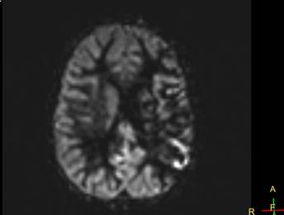

Creating color overlay

1. Scroll to area of interest ( See image above)
2. Select Color LUT- Rainbow
3. Window scale ( MM on color scale) so it starts a “0” ( See blue arrow

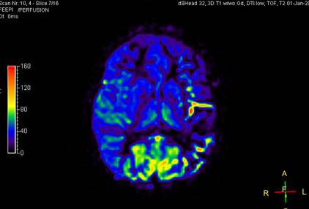

Then go to

* 1. Viewing
  2. Capture
  3. Check Slices
  4. Save to database

