Post Processing Brain Perfusion on the EWS workstation

From the worklist symbol at the top of the page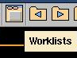 you select the patient with a single click and double click the brain perfusion sequence.
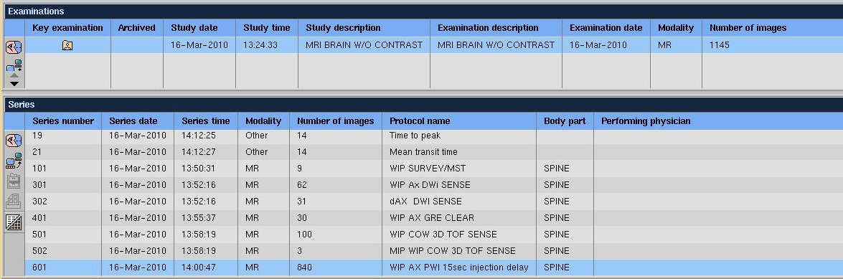
This will load the perfusion sequence into the main viewer. Click on Analysis at the top of the page. Then Quantitative Analysis.
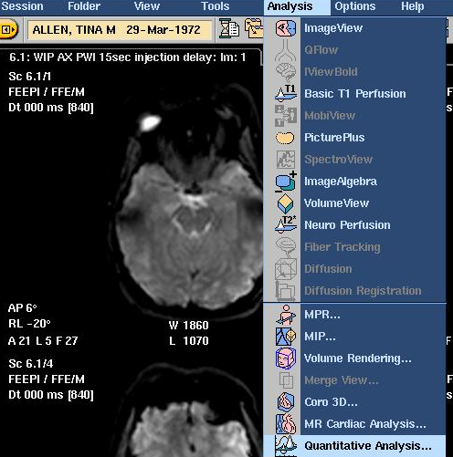

Under application, select “MR perfusion”.
Then analysis.
And adjust the masking level under analysis setup using the slide bar shown at the bottom. Make sure the mask does not exclude any parts of the brain (the whole brain should be green).

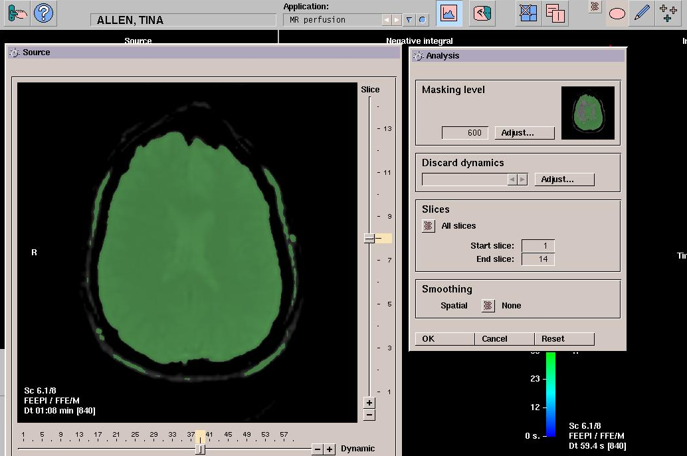
Click OK on open screens after adjusting the mask.

Then store maps using Store views. 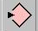
Use store key within the Store views window as well.
This stores it to the View Forum database.

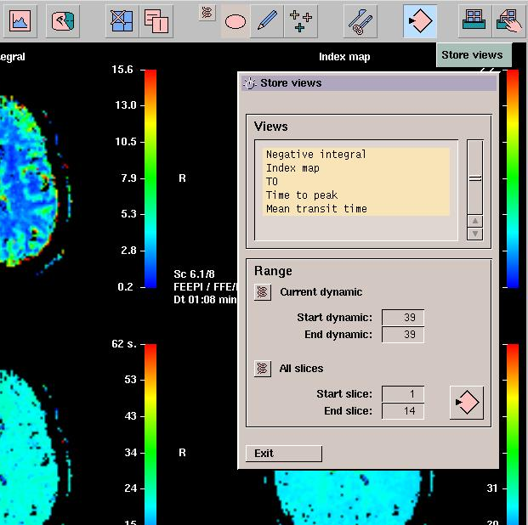
Close analysis package using doorknob key in upper left hand corner. 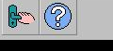

Click on worklist key at top of screen.

Single click patient’s name. Then select color maps.
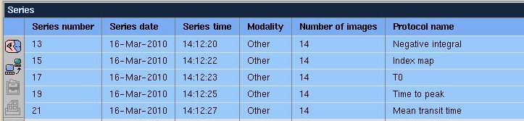
Click copy key. 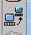

Send from View Form to Pacs and OK.
