OHSU Dept. of Orthopaedics & Rehabilitation

Knee Exercises

Nels Carlson, MD

Strengthening Quadriceps | Level One (1-2 weeks)  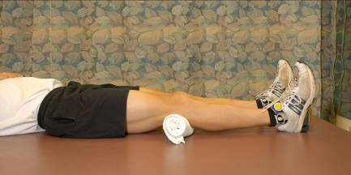 | - Lie on your back.  - Push back of knee into a rolled-up towel. Hold for 15 seconds and relax.  - Repeat five times on each leg, twice per day.
Strengthening Quadriceps | Level Two (1-2 weeks)  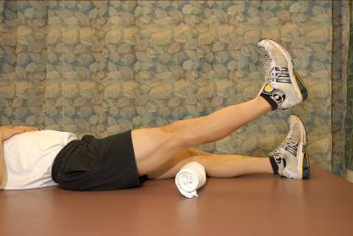 | - Push back of knee into towel.  - Left heel six inches off ground; hold for three seconds.  - Repeat five times.
Strengthening Quadriceps | Level Three (as needed)  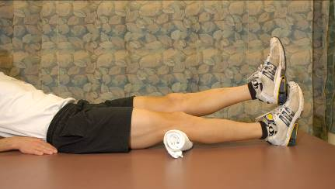  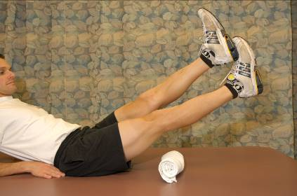 | - Push back of knee into towel.  - Touch the opposite heel to front of foot.  - Pull foot into opposite heel and lift leg six inches off the ground.  - Hold for three seconds.  - Repeat two or three times on each leg, twice per day.

Hamstring Flexibility | 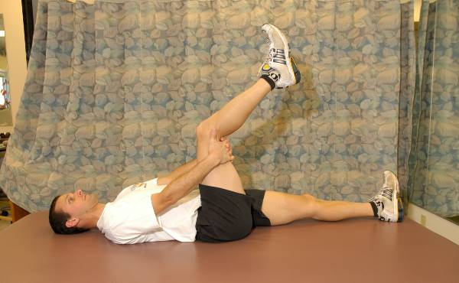  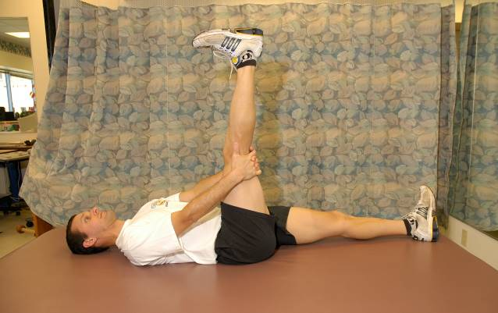 | - Lie on back. Grasp hands behind thigh so your thigh is perpendicular to the ground.  - Straighten calf up as much as possible. Hold for five seconds.  - Repeat three to five times on each leg, twice per day.

Nels Carlson, MD
Associate Professor
Physical Medicine and Rehabilitation
Department of Orthopedics and Rehabilitation
Oregon Health & Science University
3181 SW Sam Jackson Park Road
Portland OR 97239-3098
503.494.6400

