OHSU Dept. of Orthopaedics & Rehabilitation

The Famous Dr. Rainville Stretch: progressive extensor chain stretch
- Begin with feet 6 inches apart and approximately 30 inches from a table or chair back. Keep both heels on the floor. Straighten your knees and relax.
- Place forehead and forearms on edge of table (use pillow or towel as a cushion).
- You should feel a stretch behind your knees and in your calf muscle. Relax and hold the stretch for 30 seconds.
- Step feet in 6 inches closer to the table, relax, and hold at least 30 seconds. You should feel the stretch behind your knees and in the hamstring muscle.
- Step 6 inches closer, relax, and hold for 30 seconds. You should feel a stretch in your hamstring muscle and back.
- Walk as close as possible to the table or chair.
- Repeat 3 to 4 times per day.
- When stretch becomes easy, find a lower surface for your forearms and head, such as a low bureau, desk top, or arm of couch.

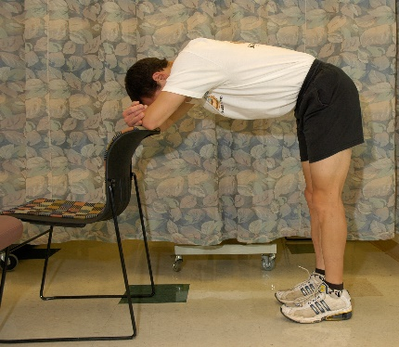  Steps 1, 2, 3 | 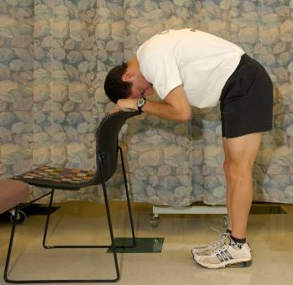  Step 4 | Step 5

