Affinity Purification Guide
Proteomics Shared Resource, OHSU

The Proteomics Shared Resource (PSR) often receives samples from Antibody Pulldown, Click Chemistry, and Streptavidin/Biotin precipitation experiments. Because of this we have put together an overview discussing some points to consider before starting, procedures, data analysis methods and costs associated with these kinds of experiments. Some of the topics discussed are:

- General Concerns
- A brief overview of different methods we commonly encounter
- LC-MS/MS method used to analyze samples
- Data analysis and results interpretation
- Approximate costs and other logistical concerns

General Concerns
Regardless of the affinity method chosen there are some general considerations that should be taken into account. Testing of a new pulldown prior to sample submission is encouraged. Smaller preliminary experiments should be done to optimize the method. One wants to assess the ability to pulldown the bait protein, the amount of material needed, the specificity of an antibody, the efficiency of the click chemistry pull outs, and other similar optimizations. Please include appropriate controls such as blank with non-transfected control cells, etc.
Consultation with PSR staff prior to sample submission is strongly encouraged. We may be able to propose other options that will help you better address your biological questions, or put you in touch with other labs who may have more experience troubleshooting methods you may be trying for the first time. If nothing else it’s helpful for us to know what kinds of samples are coming down the pipe, so we can be prepared when they arrive!

Antibody Pulldowns
Antibody pulldowns can be very informative, but have a number of hurdles along the way. The first of which is often finding a good antibody. Western blots are frequently used initially to assess the usefulness of an antibody. Because the specificity of antibodies varies it’s also important to run the affinity purified proteins into a 1D gel and check for protein bands. One would expect to see the bait protein, and well as some immunoprecipitated prey proteins/complex as well. This won’t always be an option for every situation, as some proteins will not be in high enough abundance to be seen with typical Coomassie/silver staining. However a positive result with the gel would be great indication that the procedure is working well, and will have a high probability of returning good results after submission. Be aware that while doing a western blot can confirm the presence of the bait protein in the immuno- precipitate, it will not allow you to gauge the specificity of the pull down.
Another consideration is that antibody pulldowns will generally form weaker complexes than the other options. This means that extra care needs to be taken during the washes and elution step. Washes should not include strong detergents or chaotropic agents, like SDS and urea. This means there are often non-ionic detergents left bound to the beads after washing that can interfere with subsequent LC-MS/MS analyses.
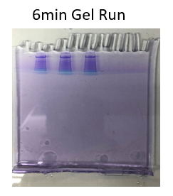
The removal of these detergents and other contaminates is often addressed by running the samples into an SDS-PAGE gel after elution. Our normal procedure runs samples into a 10% Bis-Tris gel for 6-7 minutes at 200V. This is sufficient to separate the proteins from any lingering contaminants and, upon staining, gives a rough idea about the amount of protein present.
There are volume and concentration concerns when using the gel purification step. Samples generally need to be able to have their volumes reduced by vacuum concentration to less than 30 µl while keeping the proteins soluble, and the concentration of reagents in the buffer below the point where they can cause problems with the electrophoresis. Examples of elution buffers that frequently cause problems include high salts, agents in SDS-PAGE sample buffers that increase its density, such as glycerol, and SDS, which can precipitate when raised above 10% concentration during vacuum concentration. Samples that cannot be reduced to this volume (<30ul) will need to be brought up in a greater volume after partial drying and spread across several lanes. This generally leads to lower recovery, and higher costs, since the multiple lanes increase gel volumes and processing times. An elution procedure compatible with our methods can be found on the PSR website at https://www.ohsu.edu/sites/default/files/2019-01/PSR_IP-bead_extraction.pdf.
There are a couple of noteworthy method options, the first of which is the use of magnetic beads instead of the standard agarose beads. The magnetic beads offer a smaller binding capacity, require fewer washing steps, prevent loss of beads during removal of supernatant, and have better reproducibility. However, you will need a magnetic stand, and the PSR has one that can be checked out if needed.
Another option is to use a cross-linker to bind a protein complex together, allowing for more stringent washing without losing weaker binding partners. This method can be useful for detecting weaker interactors, or more transient partners in a complex.
At the end of this document there is a section with links to a few good sources discussing various antibody pulldowns, methods, and troubleshooting. They are worth checking out.

Click Chemistry
Click Chemistry experiments can pull out specific proteins that are covalently labeled with azide or alkyne containing non-canonical amino acids, or small molecules that are covalently linked to the protein via chemical or light induced reactions (for example, diazirine derivatized drugs or lipids). Since these proteins become covalently linked to the affinity beads, the beads can be washed in succession with 1% SDS, 8M urea, and 20% acetonitrile wash solutions.
Stringent washing conditions allow these samples to be digested by simply suspending the washed beads in a trypsin solution overnight. This saves time and money when compared to the extra SDS-PAGE run-in steps needed to process most antibody samples. However, an additional peptide assay is usually needed on a new pulldown to assure there’s sufficient material to get good data from the mass spectrometer, and to make sure we don’t overload the LC column.

Streptavidin/Biotin Pullouts
For these kinds of pullouts, the bait protein is expressed with an enzyme that biotinylates proteins in proximity. These experiments can use 8M urea in wash buffers due to the strong affinity between streptavidin and biotin. Successive washes of streptavidin beads with 8M urea will usually not remove bound biotinylated proteins and will effectively remove both nonspecifically bound proteins as well as contaminating detergents that may carry over from lysis buffers. The stringent wash conditions mean that the proteins bound to the beads can be directly trypsinized by suspending the beads overnight in a trypsin solution.
We generally do not recommend protocols where strong conditions, such as boiling in SDS/biotin solutions, or washing with strong acids to elute biotinylated proteins. However, if investigators intend to use these extraction procedures, we can usually accommodate.
BioID and APEX are two examples of these kinds of experiments that allow for labelling of proteins in their natural environment. You can find links to a couple of papers detailing these methods in the final section of this document.

LC-MS/MS
Analysis on the mass spectrometer is basically the same for an IP sample as for other samples. If you’d like an overview of the basic methods used for LC-MS/MS analysis there is a .pdf on our website here: https://www.ohsu.edu/sites/default/files/2019-01/Identifying-Proteins.pdf.
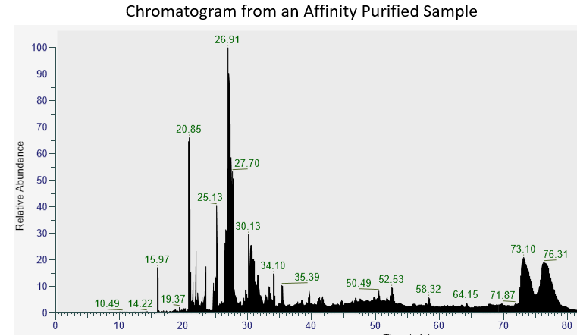
Run times are usually 60-90 min/sample depending on the complexity of the sample. About 2ug of peptide digest is our standard load amount, but this can vary based on the sample, and is often estimated from the intensity of the gel bands. Effort is not usually taken to equalize the protein amount loaded between samples, because we’re generally expecting samples to have different protein amounts present between experimental groups and controls after the affinity purifications.
Control samples are usually run first to minimize any problems with carryover, so it’s critical for us to know the order you wish us to run the samples. Standards are run before and after each run to ensure the instrument is operating well, and blanks are run in between each sample to minimize the possibility of carry over. In the event carry over is suspected, data from the blanks can be searched in the same manner as the data from the samples to identify which proteins are the result of carry over, and which are actually present in the sample.

Data Analysis
The FASTA protein database for an affinity purified sample will start with the species involved in the experiment. This may mean combining information from multiple databases if necessary (for example when exploring a virus/host interaction), and/or including the sequence of a bait protein. A list of about 180 common contaminant proteins (BSA, Keratins, trypsin, etc.) will be appended to this, along with reversed sequences of all the proteins which is used to estimate error rates. We will need all protein sequences that have a reasonable chance of being present in the sample to also be present in the database. If a protein’s sequence differs from that in publicly available databases (perhaps because of mutagenesis or a different strain being used), please provide the correct amino acid sequence so we can add it to the database.

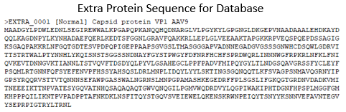

Results from the affinity purification samples are usually shared in Excel spreadsheets generated by the PAW Pipeline. These will contain a list of spectral counts for each sample lined up and color-coded by number of counts to aid in data interpretation. An overview of the spreadsheet with a walkthrough of the different columns will normally be included with your results files, however you can also find this document on our website at https://www.ohsu.edu/sites/default/files/2019-07/PAW_Pipeline_walkthrough_rv_2019_RD3.ppt.

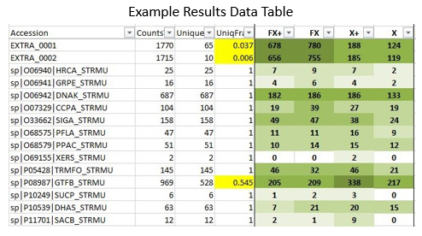
When examining the data for differences, we look for a total spectral count of around 10 between the two samples and at least a 5-fold difference between the two columns. The fold difference between the samples can be less as the total spectral count goes up (errors due to random sampling becoming relatively smaller), by the time you're around 40-50 total counts a 3-fold change could be sufficient.

If there is a large number of proteins and potential candidates, we may also perform a Sliding Window Z-Score Test. However, this is rare as many of these experiments don’t yield sufficient numbers of proteins to do this method (a large number of proteins may also indicates excessive background that hasn’t been sufficiently removed). You can find a description of this method at Phil Wilmarth’s Github site here: https://github.com/pwilmart/Z-score_GUI.

Results from these experiments are semi-quantitative. Spectral counts correlate well with protein abundance, but the correlation is not perfect, and can vary from protein to protein. Because of this, the data is best used to screen samples for large differences. Findings should be confirmed by repeat LC/MS experiments or by other means before publication.

Submitting Projects, Costs, and Other Concerns.
All sample submissions need to go through PSR’s iLab portal. You can find a link to this on our website at https://www.ohsu.edu/proteomics-shared-resource/request-services.

The turn-around time for projects is usually 2-3 weeks. Because affinity-purified samples tend to consume less instrument time, they can sometimes be squeezed in-between other larger projects in the instrument queue. However, instrument downtime, while rare, can add significant amounts of time to the queue. If there are any questions about queue time, or if there is an important deadline coming up soon, please contact us in advance so we’re aware of the potential issue, and can plan accordingly.

The cost of an experiment can vary as we charge by the hour. Many experiments have unique twists to them which make setting a firm price difficult. There’s an adage in our lab about no two samples being the same. In the end there a number of different factors that can affect the final bill, such as:

- Number of samples?
- Do we need to create a new database from scratch?
- Are you also looking for post-translational modifications such as phosphorylation?
- Did we perform the extraction step here?
- Do the samples need a shorter or longer method on the Mass Spectrometer?
- Are we doing a gel run-in or on-bead digestion?

Given all that, the price for these experiments will usually range from about $600 to $1500. If you have questions involving pricing feel free to contact us before starting your experiment. We can always give a quote. The invoice below was created using PSR’s rates as of Jan 31, 2020.

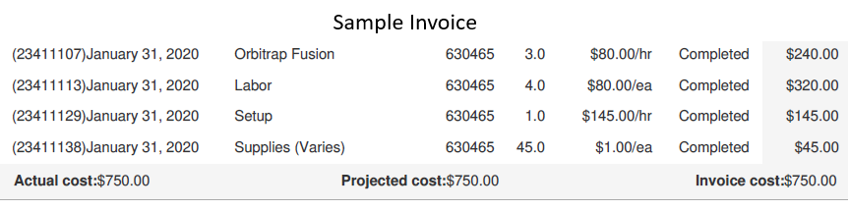

Even after taking sufficient care, preparation, and testing, multiple experiments may be needed to optimize the conditions for a new pulldown. Different wash conditions and scaling up are common corrections that may need to be done depending on the results. The end results are often worth the wait, as these kinds of experiments can yield many useful insights.

Additional External Resources
Below are a number of links to guides and publications that may be helpful with different kinds of Affinity Pulldown experiments.
Antibody Experiments
8 Tips for IP experiments
https://www.ptglab.com/news/blog/8-top-tips-for-immunoprecipitation/
Thermo Protein preparation handbook:
https://beta-static.fishersci.com/content/dam/fishersci/en_US/documents/programs/scientific/brochures-and-catalogs/guides/thermo-scientific-protein-preparation-handbook.pdf
Overview of Immunoprecipitation (IP) technique:
https://www.thermofisher.com/us/en/home/life-science/protein-biology/protein-biology-learning-center/protein-biology-resource-library/pierce-protein-methods/immunoprecipitation-ip.html#4
Co-immunoprecipitation (Co-IP):
https://www.thermofisher.com/us/en/home/life-science/protein-biology/protein-biology-learning-center/protein-biology-resource-library/pierce-protein-methods/co-immunoprecipitation-co-ip.html

Overview of Protein–Protein Interaction Analysis
https://www.thermofisher.com/us/en/home/life-science/protein-biology/protein-biology-learning-center/protein-biology-resource-library/pierce-protein-methods/overview-protein-protein-interaction-analysis.html
Excellent description of IP and Co-IP and factors to consider
https://blog.benchsci.com/immunoprecipitation-ip-principles-and-troubleshoot
Good pictures of IP and Co-IP + differences between Agarose and magnetic beads
https://www.creative-diagnostics.com/immunoprecipitation-guide.htm
Immunoprecipitation (IP) principles and troubleshooting, You Tube video
https://www.youtube.com/watch?v=OrVVZ8X3n6k
Cross-linking Publication
https://www.ncbi.nlm.nih.gov/pubmed/18438963

Click Chemistry
1235_rev1.pdf -> need external link! (from Larry)

Streptavidin/Biotin Pullouts
2 BioID Publications
https://www.ncbi.nlm.nih.gov/pmc/articles/PMC6028010/
https://www.ncbi.nlm.nih.gov/pubmed/31161514
APEX Publication
https://www.ncbi.nlm.nih.gov/pmc/articles/PMC5553119/

