Transgender Health Program
Community Advisory Board

Membership Application

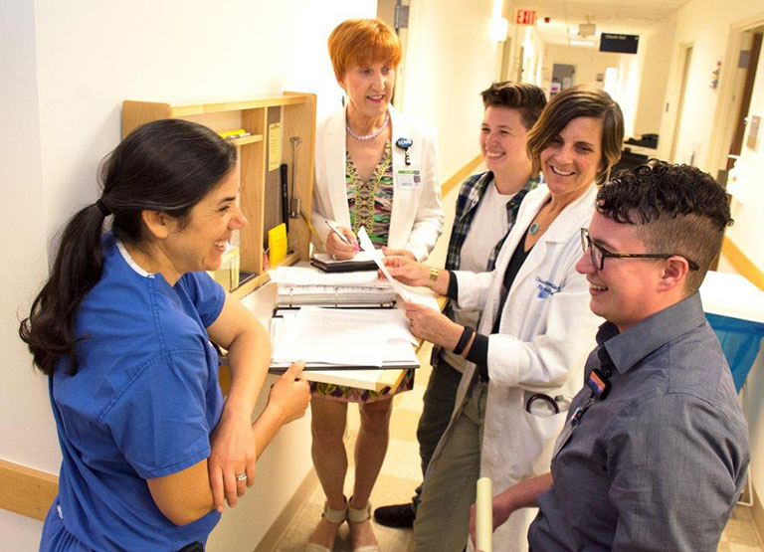

Dear Applicant:

Thank you for your interest in joining the Community Advisory Board (CAB) of the OHSU Transgender Health Program (THP). The CAB provides community feedback on our program and services and helps the THP staff stay connected to the transgender and gender nonbinary communities it serves. The THP is committed to choosing a diverse group of CAB members of different ages, income levels, gender identities, races/ethnicities, religions, sexual orientations, and abilities. The THP also seeks to maintain a CAB that represents individuals who have received services from the OHSU THP within the last three years.

The main purposes of the CAB are:

- To provide feedback about program development ideas and on-going operations from people who use our services or are representative of the communities served by the THP.
- To advise THP staff on how to improve its services.
- To offer feedback on how well the THP works with members of the community.
- To provide a community voice in decisions the THP makes about current and future services.

The mission of the OHSU Transgender Health Program is to provide safe, comprehensive, affirming health care for the transgender and gender nonconforming communities. We endeavor to improve the community's overall well-being through education, research and leadership that responds to the health care needs of transgender and gender nonconforming people.

We welcome you to join us to advance our mission.

CAB meetings will be taking place on the OHSU Campus on the 3rd Wednesday of the month from 6:15pm – 8:45pm on the following months: March, June, September, and December. Dinner will be provided at CAB meetings and transportation assistance is also available.

Membership will be determined by written application followed by in person interview. To apply please fill out the application below and email it to Amy Penkin, Program Supervisor at penkin@ohsu.edu, fax to 503-346-8310, or send by mail to:

Amy Penkin
Program Supervisor
Transgender Health Program
3181 SW Sam Jackson Park Rd
Mail Code L228
Portland, OR 97239

Thank you!

Transgender Health Program
Community Advisory Board Application

Name: Pronoun:
Date of Birth: Phone:
Email:
Demographic information:
(These responses are optional but helpful to know so we can help ensure our CAB represents diverse experiences and identities):

- Race/ethnicity:
- Sexual Orientation:
- Gender Identity:
- Education/Highest grade or degree completed in school:
- Do you consider yourself to be low income? Yes No
- Are you a person with a disability? Yes No
- Are you a veteran? Yes No

Questions:

- Are you currently an OHSU patient?

Yes No

- Have you received care at OHSU within the last 3 years?

Yes No

- Will you be able to attend 4 in person meetings a year?

Yes No

If not, what barriers do you have to attending in person meetings?

- Why are you interested in working with the CAB?

- What experience do you have as an advisor, volunteer, or community activist?

- What are your current ideas for how we could improve the Transgender Health Program?

- What do you hope to gain from participating in the Community Advisory Board?

