School of Nursing Syllabus Guidelines

Guidelines for SON Syllabus Development (April 17, 2014)

The purpose in establishing guidelines for syllabus development is to provide a consistent vehicle across courses for communicating policies and procedures to students. The following guidelines should apply to all SON courses and are designed to assist faculty in using the SON Syllabus Template. The headings below match the headings on the syllabus template.

The basis for syllabus development should be the SON Syllabus Template. Faculty can add additional headings as needed to address course specific policies or procedures. However, syllabi should not exceed 8 pages in length. (Note: the didactic and clinical components of integrated courses can be separate).

Course Description; Credit Hours; Prerequisites or Concurrent Enrollment Requirements; Term, Year, and Campus; Faculty Information; and Course Objectives, Competencies, or Outcomes are designated by program coordinators and/or approved by the appropriate Academic Council.

General Course Meeting Day and Time:
Scheduled by SON administration

Course Delivery Mode:
All syllabi should include a statement about the course delivery mode. Here are three suggested examples of statements with expectations for participation and interaction between faculty and students.

a. Synchronous Meetings: The syllabus should describe the expectations for all scheduled class meetings either face-to-face on campus, clinical settings, or online (Adobe Connect, or other tools).

Here is an example: “This course meets weekly on campus. Students must indicate if they will attend fact to face or plan to attend at a distance and connect through Adobe Connect Web Conferencing software. Intensive sessions take place as scheduled on campus and all students are requested to attend face to face.”

b. Online Course Work: The syllabus should include a concise statement that describes the expectations for how students will engage with Sakai and other digital resources/tools.

Here is an example: “This course is conducted fully online. Students are expected to log into the site regularly in order to meet course requirements and check their OHSU email accounts for notifications. Assignments are posted and submitted through the Sakai course site.”

C. Hybrid courses: The syllabus should include a statement that describes the expectations for how students will engage with Sakai outside of their face to face scheduled class time.

Here is an example: “Class meets face to face on a weekly basis. Substantial participation and homework is done on the Sakai Course Site.”

Note: For courses using Adobe Connect, please consider the following language: “You will access the Adobe Connect Web Conferencing system in the Sakai Course Site. You will also be provided with a step by step guide in the course site in Sakai that includes a link to test your computer’s readiness (testing your flash player and connection speed). Be sure to conduct this diagnostic test prior to any online class meeting. You may also contact the School of Nursing Media Specialist at soniset@ohsu.edu or 503-312-9546 with any questions you have.”

Required Texts and Readings

Supplemental Suggested Readings or Reference Materials

Attendance Requirements

Course Specific Grading Standards:
All syllabi should include information for students that describes the alignment between course outcomes, activities/assignments and assessment (evaluation). Faculty can select where the alignment table is located in the syllabus. However, syllabi must include an alignment table. Three examples follow:

Example #1:

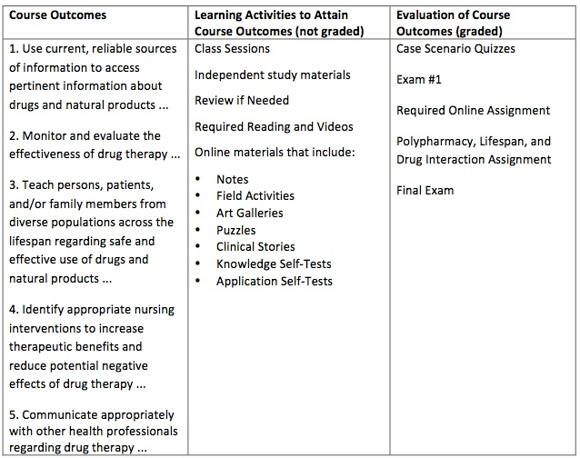
Example #2:
Percentage of Grade | Assignment | Course Outcomes/Competencies Addressed
25% | Principles of an Evolving Quality Science Forum | Construct measure and improve at least one clinical or academic organizational function. CO #1
25% | De-Constructing & Re-Constructing the Quality Enterprise | Apply quality science tools to health services and academic settings. CO #3
25% | Team: Discerning Metrics | Select valid and reliable metrics for analysis in measuring variation. CO #2
25% | Motivating Quality Capacity Presentation  (Presentation 20%; Peer Feedback 5%) | Plan an approach to capacity building that builds in and sustains quality. CO #4
Details of learning activities and these assignments are in your Sakai modules along with the grading rubrics.

Example #3:

Percentage of Grade | Assignment | Course Outcomes/Competencies Addressed
10% | Global & Specific Aims Statement | CO #1
20% | SPC Measurements & Framework | CO #1
20% | Reliability & Validity Team Work & Discussion | CO #3
20% | Structure of Change Process & Decision Points Discussion | CO #2
30% | Impact of PA on Organizational Viability JING | CO #4

Grading Criteria, Academic Standards, and Release of Final Grades:

All Syllabi should have information about when and how students are evaluated, including their course grades.

Course Content Outline:
All Syllabi should have a brief, succinct general content outline. Below is an example of a Course Content Outline:

Example

General Content Outline:
Week 1 | Cardiovascular Alterations
Week 2 | Respiratory Alterations
Week 3 | Endocrine Alterations
Week 4 | Renal & Genitourinary Alterations
Week 5 | Gastrointestinal Alterations
Week 6 | Neurological Alterations
Week 7 | Maternal-Child Nursing
Week 8 | Maternal-Child Nursing, cont’d
Week 9 | Multisystem Failure
Week 10 | Trauma

Course Specific Inclement Weather, Copyright Information, Syllabus Changes and Retention, Accommodations, School of Nursing Student Catalog/Handbook, and Technical Support

The Teaching & Learning Center can provide standard language for these headings.

Expectations for using Sakai, the learning management system:

School of Nursing faculty should use the Sakai learning management system as the predominant method for distributing course information and instructional materials. All courses should, at a minimum, use Sakai to post the syllabus and communicate with students via the Announcements and/or E-mail tools, depending on the mode of delivery (face-to-face, hybrid, fully online). The expectation is that the course will use an appropriate suite of tools in Sakai, including: Course Materials, Forums, Submissions, and Gradebook, among others.

There are three instructional designers in the Teaching & Learning Center that specialize in developing course sites in Sakai for the School of Nursing. Approximately seven-eight weeks before the start of term, SON faculty will receive a course development survey on which they should indicate their expectations for Sakai
for the coming term (importing materials from a previous term, toolset desired, etc.). Once the survey has been completed, an instructional designer will be assigned to each faculty member. The instructional designer will help the faculty member think through the design and layout of the course site and additionally consult with them on the tools and applications available to aid in the development of assignments and learning activities.

During the course development process, SON faculty should send their assigned instructional designer an updated syllabus as a Microsoft Word document. This document will be archived on the campus shared drive for accreditation and evaluation purposes as well as the facilitation of new teaching assignments for faculty. The syllabus will then be posted as a PDF in the respective Sakai site. All syllabi should be saved with the following naming conventions for the files:

- Undergraduate Course: NRS_course number_campus_term/year, i.e. NRS_231_PDX_F13.
- Graduate Course: NURS_course number_campus_term/year, i.e. NURS_611_PDX_F13.

