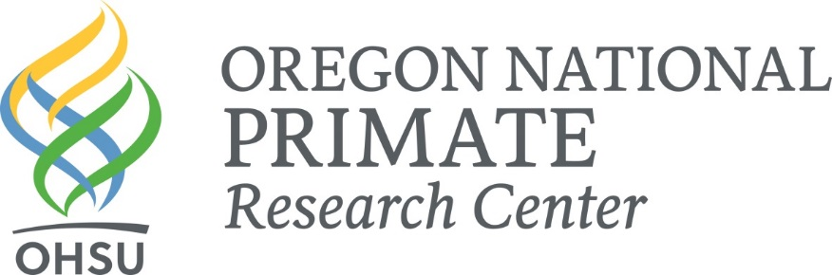

PROVOST SCHOLAR APPLICATION – COVER PAGE

You are eligible to apply to the OHSU/Primate Center Provost Scholar Program if you:
- attend a 4-year college/university in the State of Oregon;
- will have completed at least two undergraduate college years by June of 2019;
- come from a cultural background that is underrepresented in the health and science professions (includes American Indian or Alaska Native; Black or African American;
Native Hawaiian or other Pacific Islander; Hispanic or Latino);
- are a US citizen, permanent U.S. resident, or eligible DACA student (Deferred Action for Childhood Arrivals). A DACA applicant must have an employment authorization card via USCIS.

Please type your answers. Handwritten applications may not be considered! ALL application materials (including resumes, transcripts, and letters of recommendation) must be received no later than 11:59 p.m. on February 1, 2019. Applications that are incomplete as of this deadline will not be considered.

Name: ________________________________________________________________________
Last First Middle Initial

Gender: Female Male Transgender Prefer Not to Say

Race: American Indian or Alaska Native
Black or African American
Native Hawaiian or Other Pacific Islander
Hispanic of any race
Other
Two or more races

If other, please specify: _______________________________

Current Mailing Address: _____________________________________________________

_____________________________________________________

Telephone Number: _____________________________________________________

Permanent Mailing Address: _____________________________________________________
(if different from above)
_____________________________________________________

Telephone Number: _____________________________________________________

E-mail Address: _____________________________________________________

U.S. Citizen/Permanent Resident? Yes No

Eligible DACA Student? Yes No

FAMILY AND BACKGROUND:

Are you a first generation college student (i.e., the first person in your family to attend college)?

Yes No

Parent/Guardian 1 education level high school
GED
Some college
College graduate
Other

If “other,” please specify: ______________________________________________

Parent/Guardian 2 education level high school
GED
Some college
College graduate
Other

If “other,” please specify: ______________________________________________

Are you fluent in a language that is not English? Yes No

If so, specify the language(s): ______________________________________________

HOUSING NEEDS:

I will need housing during the program.

I will not need housing during the program. I have housing in or near Portland with family or
friends.

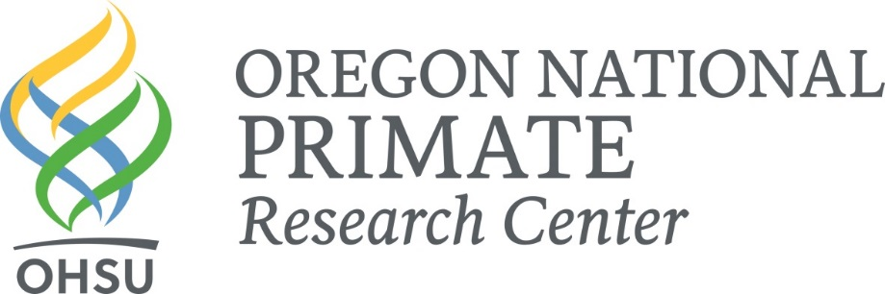
APPLICATION FOR THE
PROVOST SCHOLAR PROGRAM

You are eligible to apply to the OHSU/Primate Center Provost Scholar Program if you:
- attend a 4-year college/university in the State of Oregon;
- will have completed at least two undergraduate college years by June of 2019;
- come from a cultural background that is underrepresented in the health and science professions (includes American Indian or Alaska Native; Black or African American;
Native Hawaiian or other Pacific Islander; Hispanic or Latino);
- are a US citizen, permanent U.S. resident, or eligible DACA student (Deferred Action for Childhood Arrivals). A DACA applicant must have an employment authorization card via USCIS.

Please type your answers. Handwritten applications may not be considered! ALL application materials (including resumes, transcripts, and letters of recommendation) must be received no later than 11:59 p.m. on February 1, 2019. Applications that are incomplete as of this deadline will not be considered.

Name: ________________________________________________________________________
Last First Middle Initial

Gender: Female Male Transgender Prefer Not to Say

Race: American Indian or Alaska Native
Black or African American
Native Hawaiian or Other Pacific Islander
Hispanic of any race
Other
Two or more races

If other, please specify: _______________________________

Current Mailing Address: _____________________________________________________

_____________________________________________________

Telephone Number: _____________________________________________________

Permanent Mailing Address: _____________________________________________________
(if different from above)
_____________________________________________________

Telephone Number: _____________________________________________________

E-mail Address: _____________________________________________________

Possible starting date*: _________________ Ending date: ______________
(must start by the last week in June) (must participate in Symposium, August 14, 2019)

EDUCATION:
Name and Location Year of Graduation Degree (if any)

High School: _________________________________________________________________

College/Univ.: _________________________________________________________________

_________________________________________________________________

Graduation Date and Degree Expected: ______________________________________________

Major: ________________________________ Minor: _________________________________

RESEARCH EXPERIENCE:

Do you have any research experience? Yes No

If yes, please describe your experience:

Mentoring is a time-consuming endeavor that is taken seriously by the scientists at the ONPRC, who devote a great deal of time, energy, and lab resources to such training. Because of this, summer internships are awarded for 10-week periods during which students should plan to spend at least 40 hours per week in the lab. In addition, recipients of these awards are required to attend a weekly seminar series and present a talk at annual Summer Science Symposium, scheduled for Wednesday, August 14 2019.

To assist us in matching you to the appropriate mentor, please answer the following questions:

- What prompted your interest in the Oregon National Primate Research Center (i.e. personal interest in research, school requirement, etc.)?

- Describe your interest in science/research. In what way(s) do you foresee your training here at the Primate Center impacting your future?

- What are your personal goals for this experience?

- What knowledge, skills, and/or abilities will you bring to the lab? (Be as specific as possible, listing lab techniques and skills that you possess or have learned in your classes.)

- What conflicts/restrictions on your available time should we be aware of, should you be selected for an award (family vacations/weddings/etc.)?

- Check one or more labs in which you have an interest:

Dr. Kristine Coleman Dr. Jon Hennebold
Dr. Rita Cervera-Juanes Drs. Alejandro Lomniczi/Hollis Wright

Dr. Larry Sherman

- Please send transcripts from college(s) or university/ies you have attended (unofficial transcripts are fine).

- Please send a copy of your resumé/curriculum vitae (CV).

- Please provide 2 letters of recommendation from individuals who are not related to you (at least one from a current/former college science professor). The second recommendation can be from a community leader, teacher, coach, counselor, etc. Provide the names and contact information for these individuals below.

Name Address Telephone Number

- __________________________________________________________________________

- __________________________________________________________________________

All successful applicants are required to make a presentation of their research at the annual Summer Science Seminar, scheduled for Wednesday, August 14, 2019. Please sign below to indicate that you are aware of and able to honor this requirement.

Signature: __________________________________________ Date: _______________

Research that takes place at the Oregon National Primate Research Center/OHSU is undertaken to improve understanding of human health and disease. Animal models are essential in this pursuit, and students need to be aware that in certain cases invasive animal procedures are necessary. Ethical issues associated with research in humans and other animals can evoke strong controversy, yet animal research is presently our only means of answering certain critical questions that we hope will lead to improved therapies and/or cures for disease. Federal law mandates adherence to regulations that ensure our research procedures are both humane and justified in terms of their contribution to knowledge and medical practice.

I understand that animal research takes place at the Oregon National Primate Research Center. I support the ethical conduct of animal research that is carried out in compliance with federal laws and regulations.

Signature: __________________________________________ Date: _______________

Application materials may be sent by US Mail to:

Diana Gordon
Education & Outreach Coordinator
Oregon National Primate Research Center
505 NW 185th Ave.
Beaverton, OR 97006

…by e-mail to: gordondi@ohsu.edu

…OR by FAX to: (503) 346-5015 (Attention: Diana Gordon)

APPLICATION CHECK LIST:

Your complete application must include:

Completed Typed Application (handwritten applications may not be read)

Transcript(s) (unofficial transcripts are sufficient)

Resumé/Curriculum Vitae (CV)

Letters of Recommendation (2): Letters of recommendation may be sent directly to
Diana Gordon via e-mail or U.S. mail (see contact information, above), or may be
included in an application packet with other materials. Letters of recommendation sent
in this way should arrive in sealed envelopes with the signature of the recommender
across the flap. Letters of recommendation must be received by 11:59 p.m. on
February 1, 2019. It is YOUR responsibility to ensure that these letters arrive on time!!!

ALL application materials (including transcript(s), resumés and
letters of recommendation) must be received no later than
11:59 p.m. on February 1, 2019.

If you have questions or need additional information, please contact
Diana Gordon by phone (503-346-5055) or email (gordondi@ohsu.edu)

