How to Apply to Graduate Online
- Log into Self Service using your U-number and password
- Select Student records
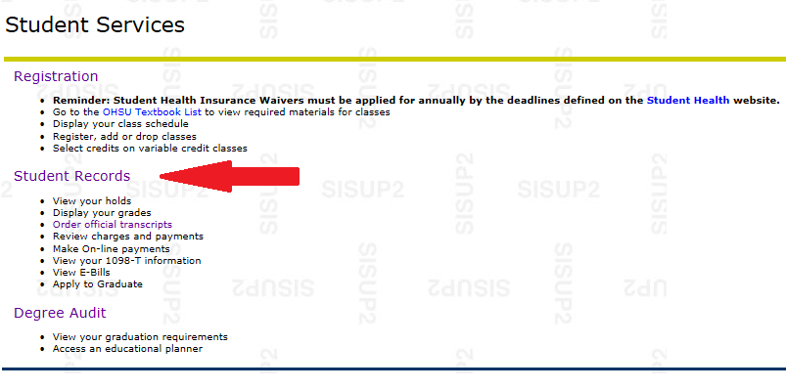
- Select Apply to Graduate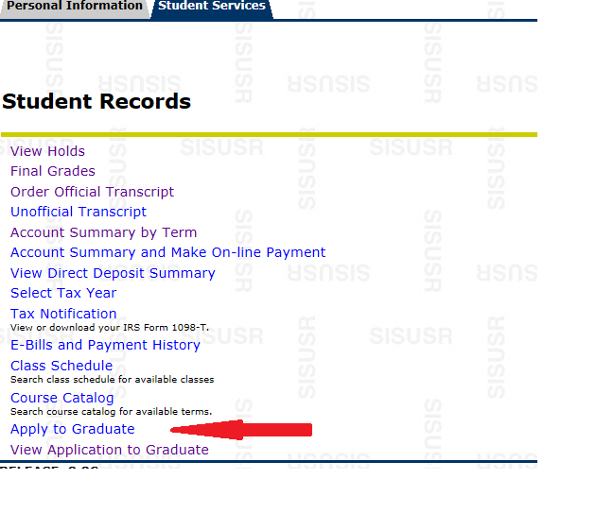

- Your program term is pre-selected so just click the submit button

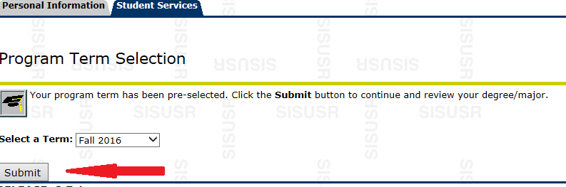

- Review your program information and make sure it is correct. If it is, then select current program and click continue. If it is not correct, contact the Registrar’s Office at regohsu@ohsu.edu or call 503-494-7800.
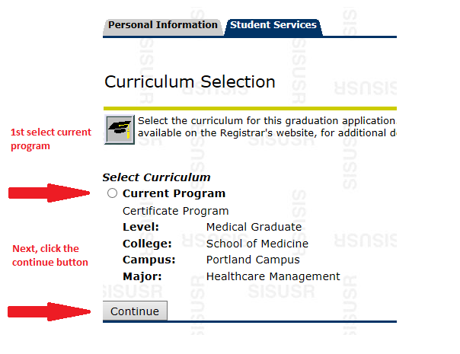
- Choose the term in which you plan to graduate from the drop-down menu, then click continue
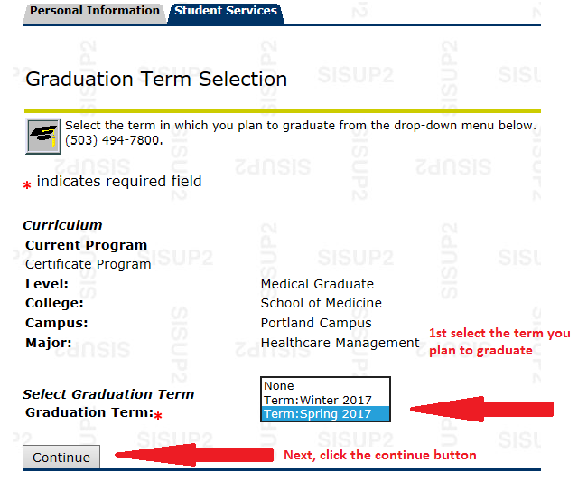
- Graduation ceremony selection. If you plan to attend the Convocation/Hooding & Pinning Ceremony in June, select ‘Yes’. If you do not plan on attending, select ‘No’. If you are not sure, select ‘Undecided’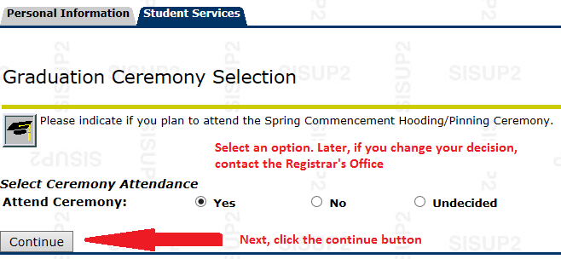
- Review your name and if it looks correct then select current name. If your name has changed, but you have not updated your student record, go to www.ohsu.edu/registrar and follow the directions on the change of address/name form. WE CAN ONLY PRINT YOUR NAME AS IT APPEARS IN YOUR STUDENT RECORD

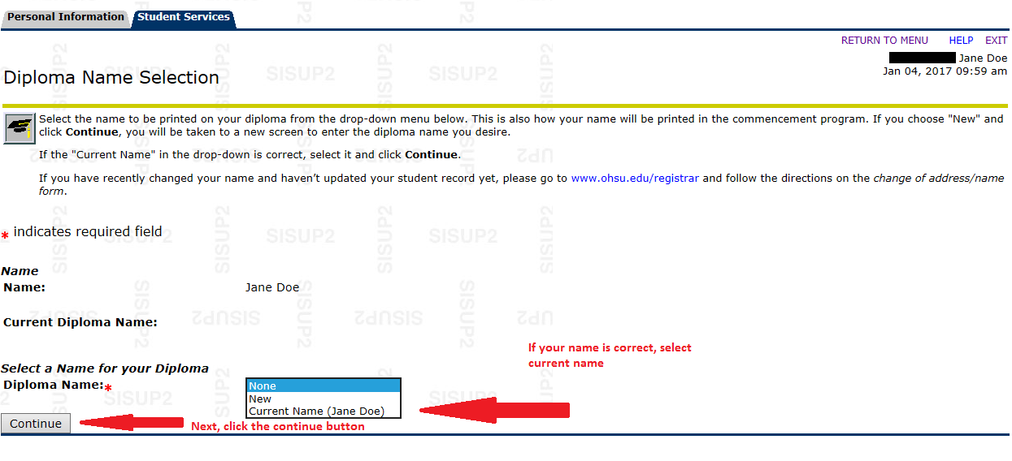

- Confirm name again and click continue

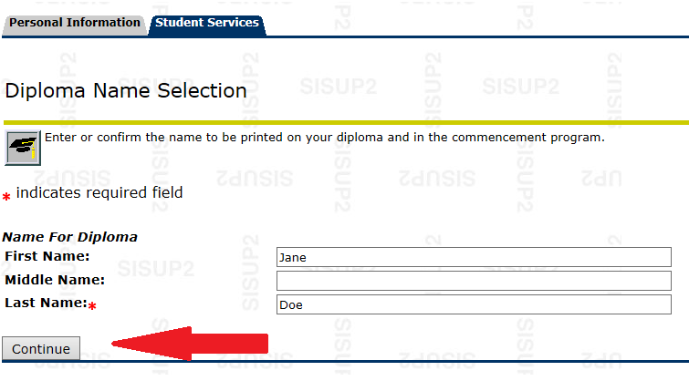
- Select the address where you would like your diploma to be mailed. If you do not see the correct address listed, select new and enter your correct address
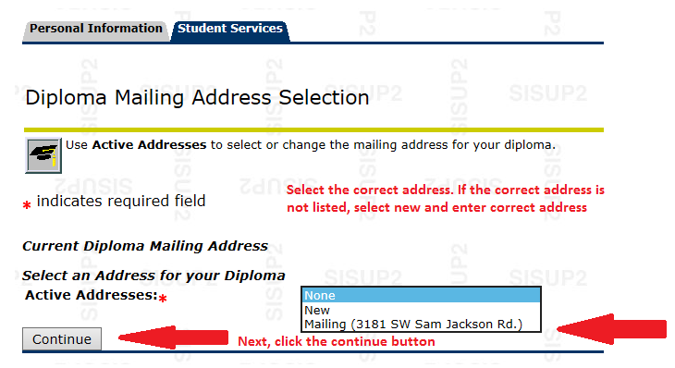

- Confirm your address again and click continue

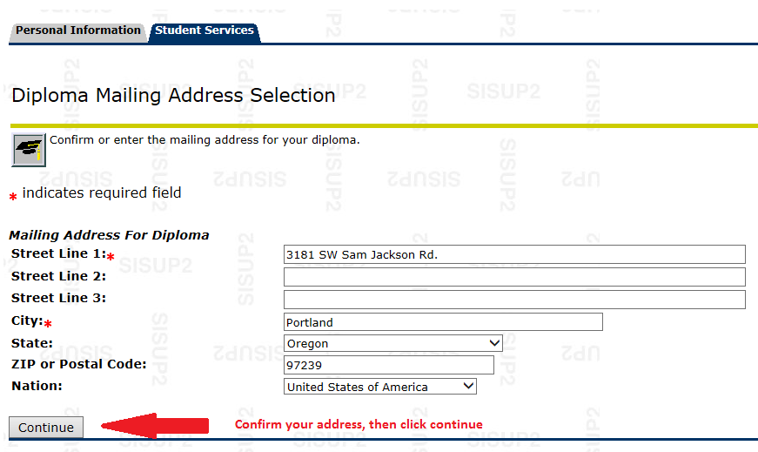

- Review all of the information listed on your graduation application. If everything is correct then select Submit Request. If your program information is not correct then contact the Registrar’s office at 503-494-7800.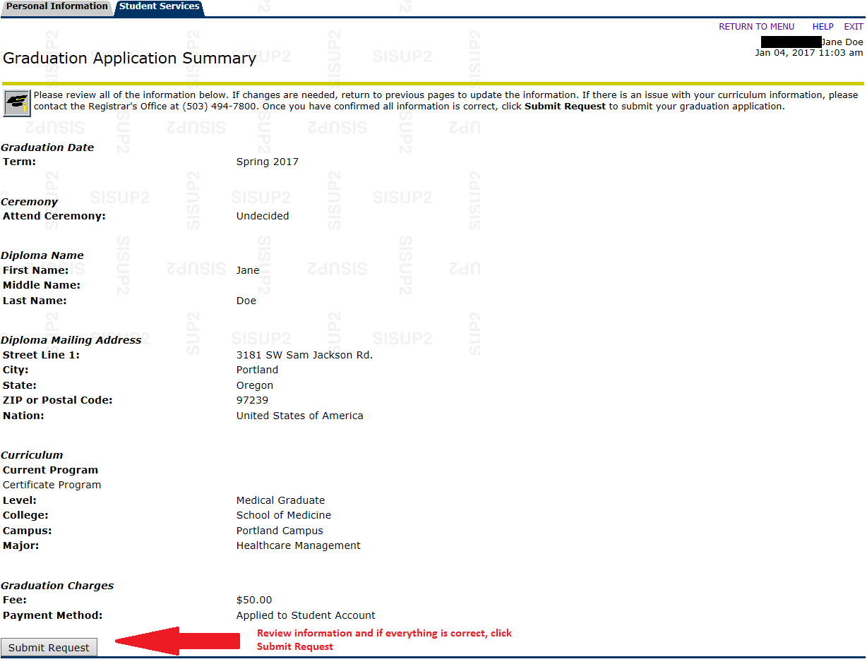
- You will see a confirmation page confirming that your graduation application has been submitted and that is when you know that you have applied to graduate!

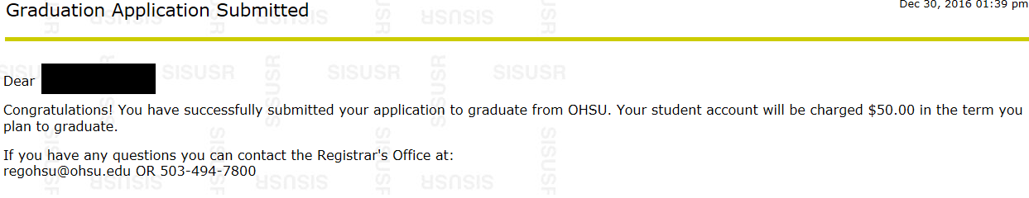

- You can also view your submitted application by selecting the student records and then selecting view application to graduate

