MRI Tip Sheet: Pushing to “NQ_MS_PLUS” from EIPACS

- Search for your patient info in PACS and open the most recent study for viewing.

- Once the exam is open, right-click on one of the images and select “Print and Export”:

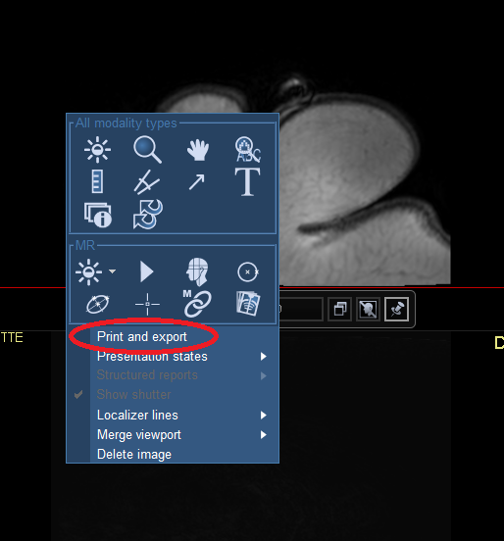

- In the new window that appears, at the top click the tab that says “Dicom Transfer” and then click the button that says Tagged images or Series:

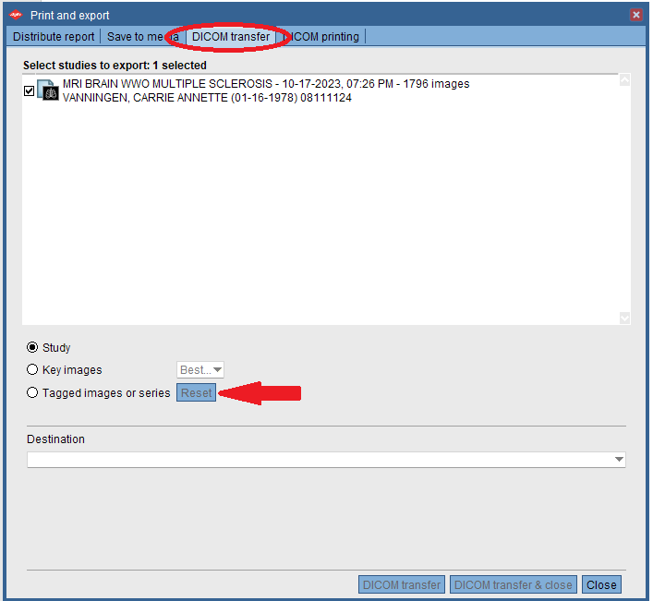

- When you click the tagged images or series, your cursor will change to one with a blue “carrot” next to it:

- You want to click on the thumbnail of the series in order to select all images in the series (if you click on just the image in the viewer, it will only select that single image and not the entire series):

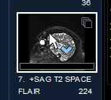
- Click on the Thumbnail for the 3DT1 and 3DFLAIR. The thumbnail will then have a solid version of the same blue carrot that is next to your cursor:

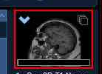

- Once those two series are selected, choose the Node “NQ_MS_PLUS” in the destination drop down (you’ll have to scroll a lot to get there):

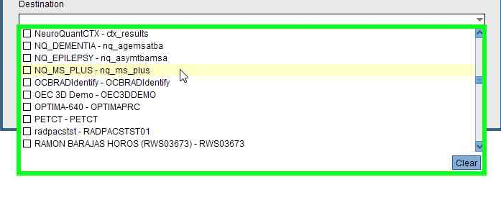

- Once that selection is made, click “Dicom transfer & close” to have the images pushed to the NQ node:

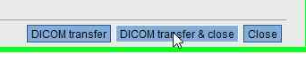
- You’ll get a pop up that says the images have been transferred, and then you can log out of EI PACS – the processing time for the MS Quant is a bit longer than the other NQ nodes – you can expect the report to take about 30 minutes. As long as that report is being processed before any new acquisitions, it will process the longitudinal data for MS Lesions.

